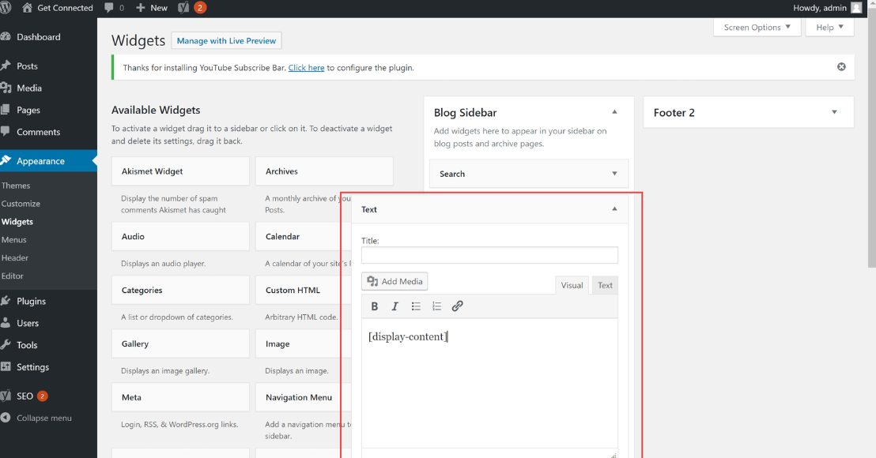

WordPress Course Understanding Widgets

Introduction:
Hi everyone, and welcome back to another video in our WordPress course. This is our 5th lecture, and today we will dive into the topic of Widgets in WordPress.

If you've been following the course, you've already learned about themes and customization options in WordPress. Today, we'll explore how widgets can enhance the functionality and design of your website by adding useful features like recent posts, search bars, and more.

Step 1: Accessing the Dashboard
To begin with, let’s go to your WordPress dashboard. The dashboard is where you manage everything on your website, from posts to design. If you’ve already installed WordPress and logged into your account, you’ll see the main interface.
- From the dashboard, you’ll find a menu on the left-hand side. This menu is where you will control various aspects of your WordPress website.
- As we’ve discussed in earlier lectures, there are several menus related to the design and structure of your website. One of these menus is Appearance, which is crucial for managing themes, widgets, and customization options.
In today’s lesson, we are focusing on Widgets under the Appearance menu. Widgets are small blocks that perform specific functions and can be added to areas like sidebars and footers on your website.

Step 2: Exploring the Widgets Section
Once you’re in the Appearance menu, you will find the Widgets section. Let’s take a closer look at what we can do with widgets.
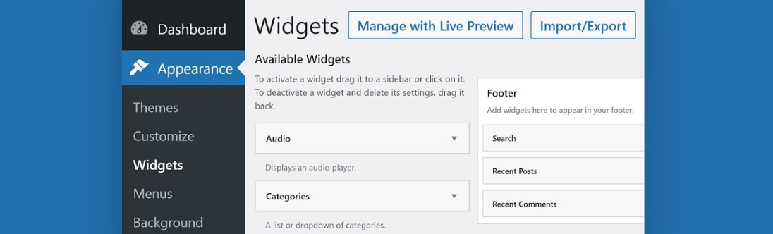
- Widgets are pre-designed elements that can be placed in specific areas of your theme, such as the sidebar or footer. These widgets can add functionality to your website, like displaying recent posts, search bars, categories, or even custom text.
- By default, most WordPress themes come with a few basic widgets already set up. For example, your right sidebar might have widgets like Recent Posts, Comments, and Categories already displayed.
- On the left sidebar, however, you will likely see no widgets added yet, which means we can customize it based on our preferences.

Step 3: Adding a Widget to the Left Sidebar
Now, let's move forward and add a widget to the left sidebar. This is a great way to personalize your site and add useful elements for your visitors.
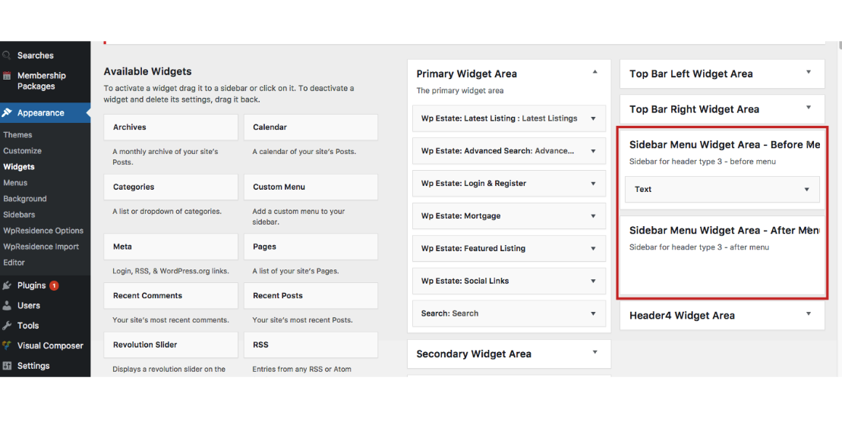
- Click on the "Add Block" button: In the widget section, you will see an option to add blocks. Blocks are the individual elements or widgets you can add to your sidebar.
- Choose the widget type: For this example, we are going to add a Heading. Headings are useful for categorizing content or providing structure to your sidebar.
- Enter the content for your heading: Type in a heading that reflects the content you want to highlight. For example, “Latest Updates” or “Categories” could be appropriate for your sidebar.
- Add a paragraph block: After the heading, you might want to add some additional content. You can do this by adding a Paragraph block below the heading. Type in some text, such as “Here are the latest posts and updates from our blog.”

Step 4: Customizing the Sidebar Settings
Once you’ve added your widgets, it’s time to customize your sidebar settings to make sure everything looks perfect.
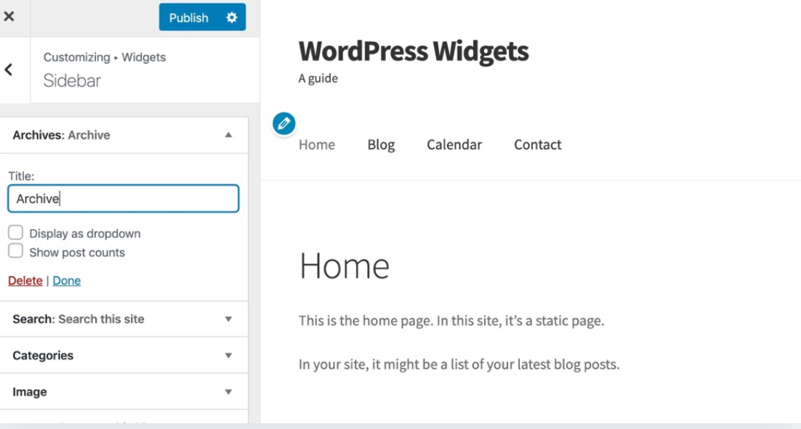
- To begin, navigate to the Customizer under the Appearance menu.
- The Customizer allows you to modify the appearance of your theme, including the placement of widgets. In the customizer, you can see real-time changes as you tweak the settings.

Sidebar Settings for Posts and Pages
In the sidebar settings, you can decide where your widgets should appear. For instance:
- Single Post or Page Settings: If you want to show the sidebar on specific posts or pages, you can control this in the customizer. You can choose whether the sidebar should appear on every page or only on particular ones.
- Adjusting the Layout: You can also adjust the layout to decide whether the sidebar appears on the left or right of the content.
For our example, let’s choose to display the sidebar on the right side of the page. This layout works well with many WordPress themes and helps keep the content area clean.

Step 5: Selecting and Publishing the Sidebar
After customizing your sidebar, it’s time to publish the changes.
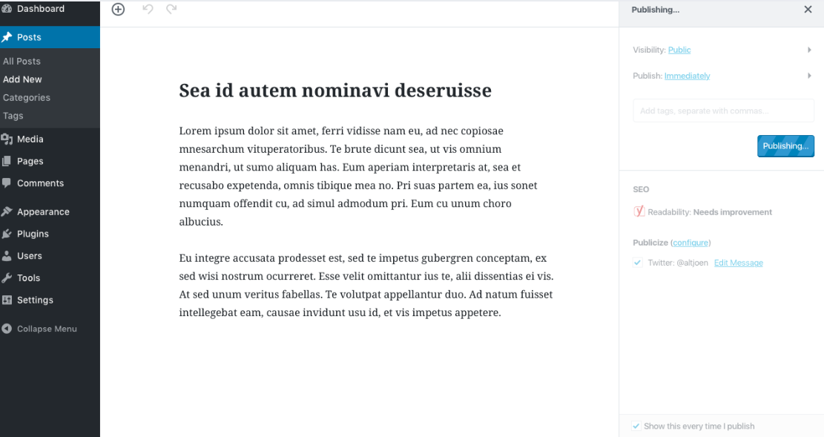
- In the customizer, select the Right Sidebar to make sure the widgets appear in the right column of your website.
- Click on Publish once you’re happy with the setup. This will apply your changes live to your site.

Step 6: Refreshing the Page
Once the sidebar settings are updated and published, the next step is to refresh your website to view the changes.
- After refreshing, you’ll notice the right sidebar now contains the widgets you added earlier, such as Recent Posts, Comments, Search Bar, Archives, and Categories. These are all elements that visitors can interact with, helping them find relevant content on your site.

Step 7: Adding a New Blog Post
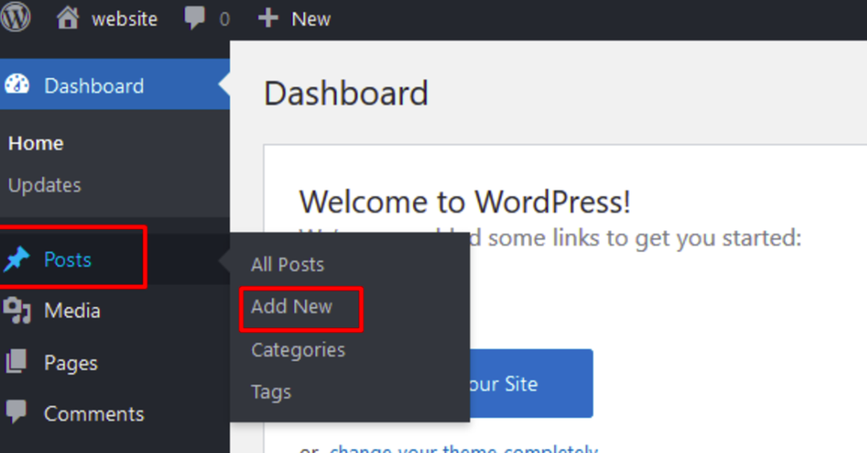
Now that your sidebar is updated, you might want to add some content to your blog. Let’s add a new blog post and see how the sidebar looks alongside the new content.
- To add a blog post, go to the Posts section in your dashboard.
- Click Add New, then write and publish your post as usual.
- After you publish the post, the sidebar will automatically update to display relevant widgets, like the latest posts or recent comments, depending on how you’ve configured it.
That’s all for today’s lecture! You’ve now learned how to manage and add widgets to both the left and right sidebars in WordPress. By customizing the widgets and adjusting the sidebar settings, you can enhance the functionality and user experience of your website. This simple customization can help make your site more dynamic and user-friendly.

Thank you so much for following along, and I look forward to seeing you in the next video!

