

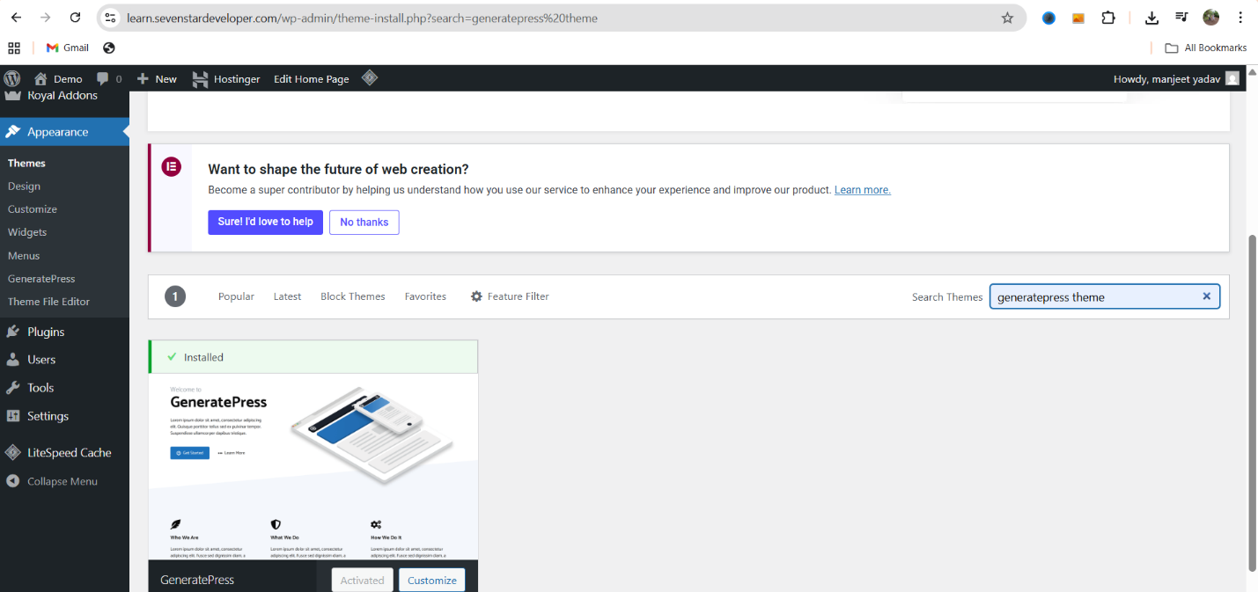

WordPress Theme Install and Customization
Introduction:
Hi everyone, and welcome back to another exciting video in our WordPress course! In today’s 4th lecture, we’re diving deep into the install and customization of WordPress themes. Customizing a WordPress theme is an essential part of building a personalized website.

It helps you align your website with your brand identity, ensuring it not only looks professional but is also easy for users to navigate. Whether you’re new to WordPress or have some experience, today’s tutorial will give you the insights needed to customize your theme effectively.

Install a Theme from the WordPress Repository
Use this when you want a free theme from WordPress.org (e.g., GeneratePress
, Astra, Neve, Storefront).
- Log in to your WordPress Admin Dashboard (yourdomain.com/wp-admin).
- In the left menu, go to Appearance → Themes.
- Click Add New at the top.
- Use the Search box to find a theme by name or feature (type “Astra”, “Neve”, or “blog”, “portfolio”).
- Hover over the theme card and click Install.
- After install finishes, click Activate.
- Visit your site (front end) to verify the theme is applied.
Example: Installing “Generate press”
- Appearance → Themes → Add New → search “Generate press” → Install → Activate → Visit site.

Step 1: Accessing Theme Customization
- Navigating to the Theme Customization Panel
The first thing you need to do is go to your WordPress dashboard. Once there, you’ll find a section labeled Appearance. When you hover over the "Appearance" tab in the sidebar, you’ll see the Customize option.
Click on it to open the Theme Customization panel. This is where all the magic happens. Here, you can tweak various aspects of your website’s appearance to match your brand or personal style.

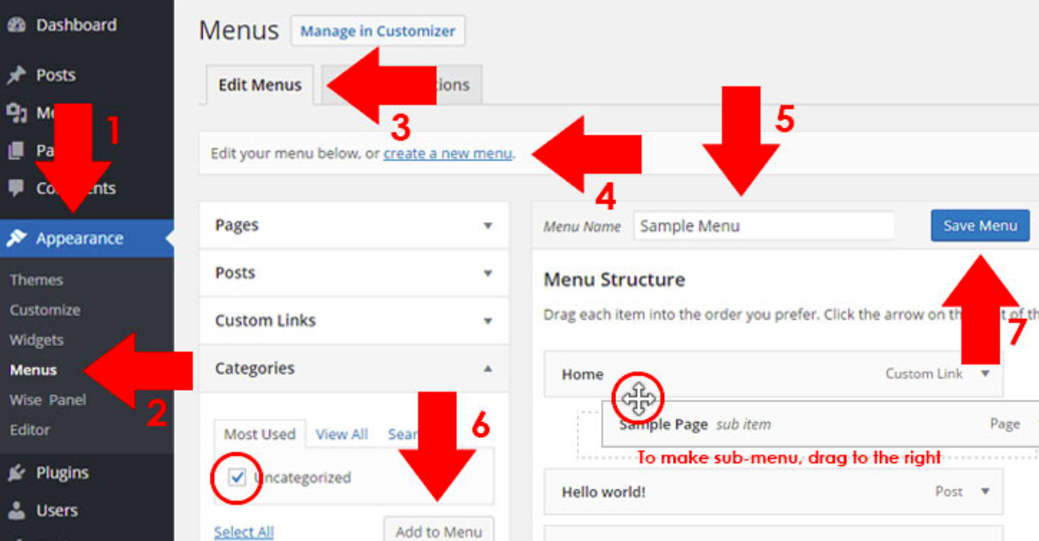

Comprehensive Guide to Creating and Managing Menus in WordPress
Welcome to our 8th lecture in the WordPress course! Today, we will focus on how to create, edit, and manage menus in WordPress. By the end of this guide, you will understand both the basics and advanced options for menu customization.

Step 1: Arranging Pages for Menus
To create a well-structured menu, start by organizing your pages.
- Access the Pages Section:
  - Navigate to the WordPress dashboard.
  - Click on Pages to view all your created pages.
- Set Page Order:
  - Hover over the desired page (e.g., "About Us") and select Quick Edit.
  - In the Order field, assign a number (e.g., 1, 2, 3). This determines the sequence of your pages in the menu.
  - Repeat this process for all pages.
- Update the Order:
  - After assigning numbers, click Update to save changes.
  - Refresh your site to see the updated order reflected in the menu.
Organizing your pages in the correct order ensures that the menu appears structured and intuitive to your visitors.

Step 2: Creating Menus in the Appearance Section
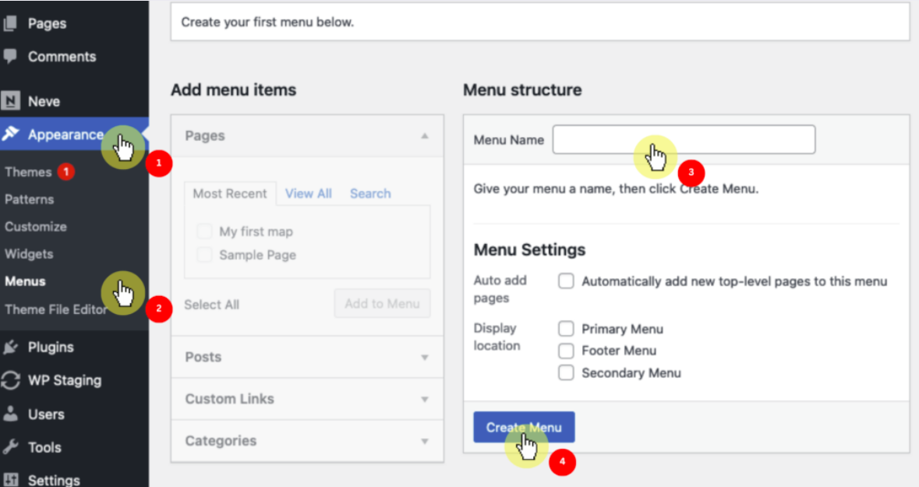
Another way to manage menus is through the Appearance section in the WordPress dashboard.
- Access Menus:
  - Go to Appearance > Menus.
  - Here, you can create, delete, or reorder menu items.
- Add Pages to the Menu:
  - Select the pages you want to include in the menu from the available list.
  - Click Add to Menu to include them.
- Reordering Pages:
  - Drag and drop the menu items to arrange them in your desired order.
  - To create a submenu, drag a page slightly to the right under a parent menu item.
  - Click Save Menu after making changes.
This method allows you to create menus tailored to your site's content and layout.

Step 3: Using the Customizer for Menus
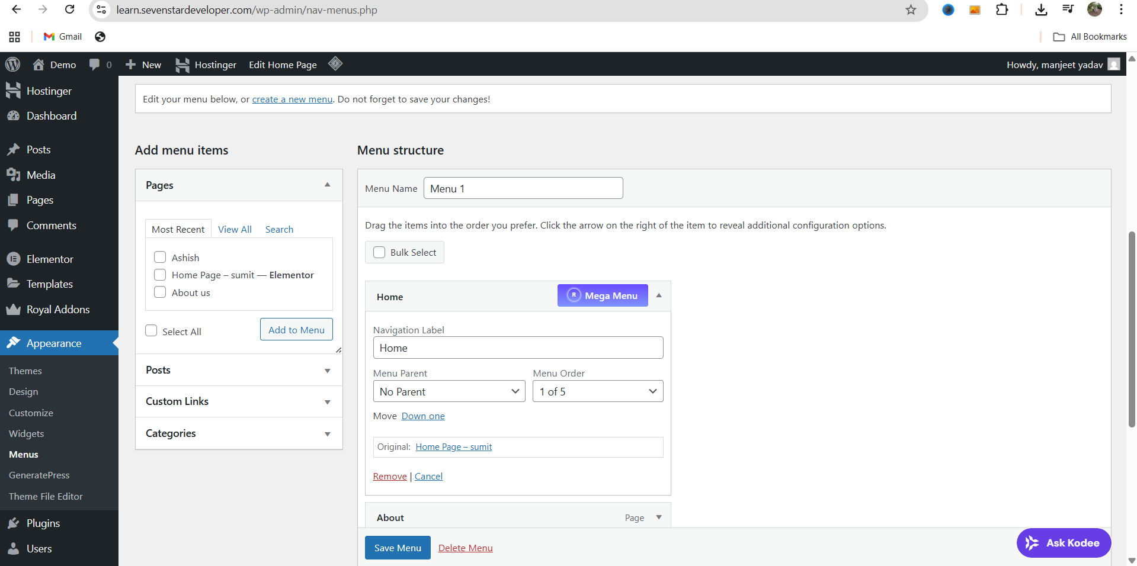
The WordPress Customizer offers another way to manage menus with a live preview.
- Access the Customizer:
  - Go to Appearance > Customize.
  - Select Menus from the available options.

- Edit Menus:
  - Choose the menu you want to modify.
  - Add, remove, or reorder items as needed.
  - Use the drag-and-drop interface to create submenus or reorder items.
- Save Changes:
  - Once you’re satisfied with the changes, click Publish to apply them to your site.
The Customizer is ideal for visually editing menus while observing real-time updates on your site.

Step 4: Advanced Menu Options
Explore additional options for enhancing your menu functionality.
- Navigation Styles:
  - Customize the appearance of your menu through your theme settings.
  - Adjust font styles, colors, and layouts to align with your site design.
- Submenus:
  - Add dropdown menus by placing child items under a parent menu item.
  - Drag and drop items in the menu editor to create these hierarchies.
- Duplicate Menus:
  - Use the duplicate option to create a backup or replicate a menu for another section of your site.
- Delete Menus:
  - To remove a menu, select it and click Delete Menu in the editor.
- Adding Custom Links:
  - In the menu editor, select Custom Links to add external URLs or anchor links.
  - Enter the URL and link text, then click Add to Menu.
These advanced options offer flexibility and control, allowing you to create professional and user-friendly menus.

Step 5: Finalizing and Reviewing Changes
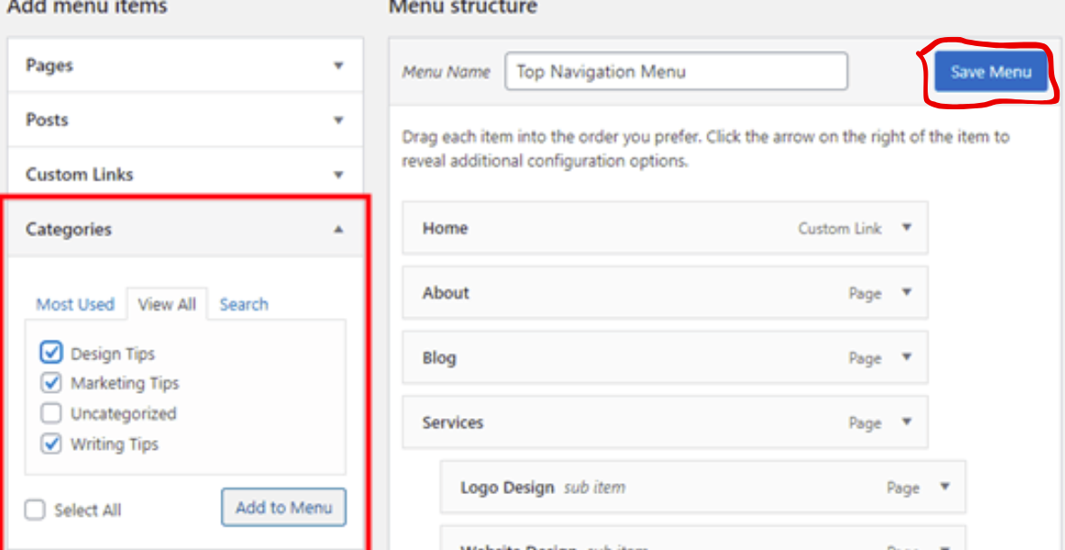
After setting up your menus, ensure everything works as intended.
- Save and Refresh:
  - Save your changes and refresh your site to see the updates.

- Test Navigation:
  - Navigate through your menus to verify links and functionality.
  - Check for broken links or incorrect page assignments.
- Backup Menus:
  - Use a plugin or manual method to back up your menu settings.
  - Keeping a backup ensures you can restore menus if needed.

Practical Tips for Menu Optimization
- Keep It Simple:
  - Avoid overcrowding your menu with too many items. Focus on key pages.
- Use Descriptive Labels:
  - Label menu items clearly to guide visitors effectively.
- Prioritize Important Pages:
  - Place high-priority pages, such as "About Us" or "Contact," at the beginning.
- Mobile-Friendly Design:
  - Test menus on different devices to ensure responsive and intuitive navigation.
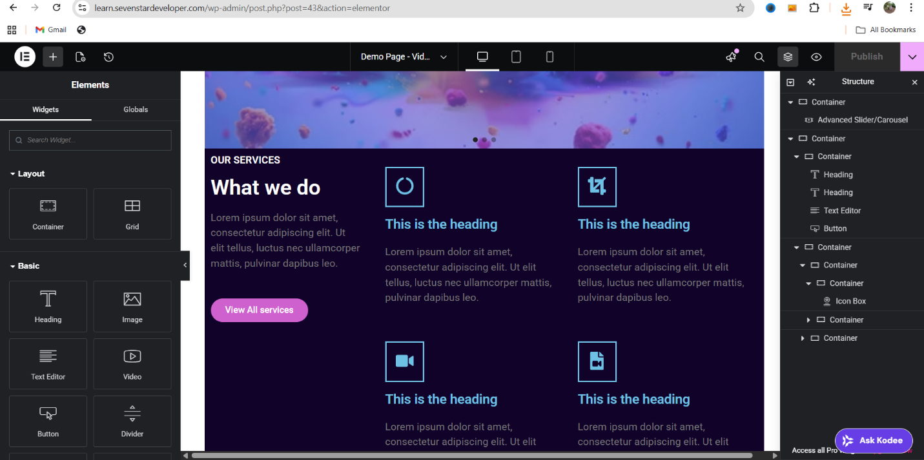

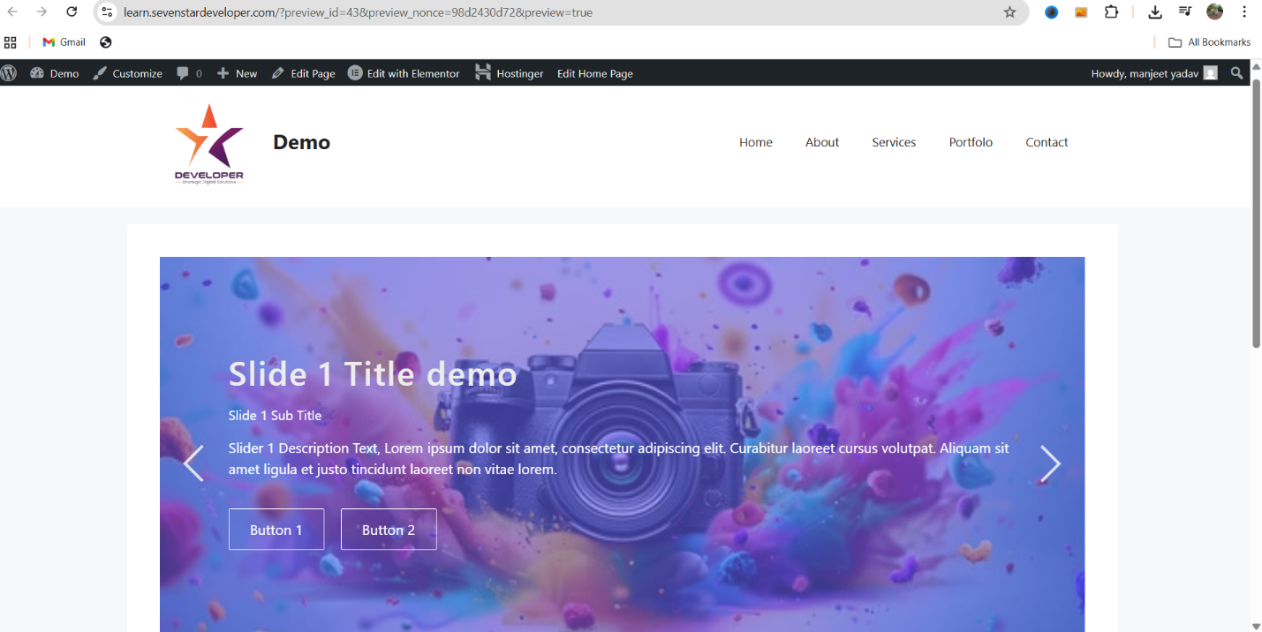

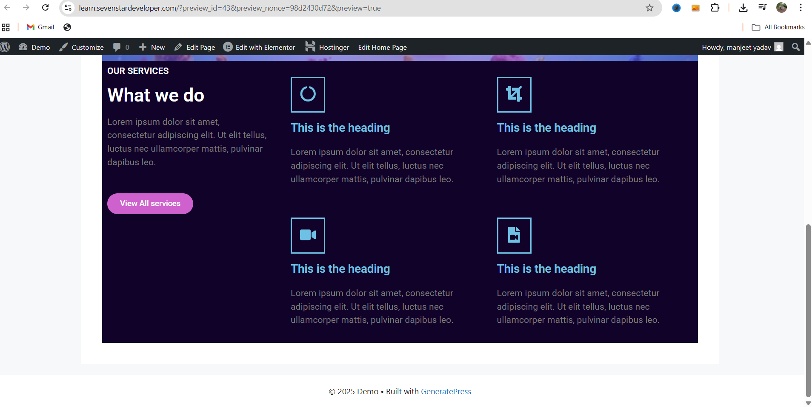
By following these steps, you can efficiently create and manage menus in WordPress. Menus play a crucial role in site navigation and user experience. Regularly review and update them to keep your site organized and user-friendly.
We hope this lecture provided valuable insights into menu management. Don’t forget to like, subscribe, and share our channel. Let us know your thoughts in the comments! See you in the next video.

