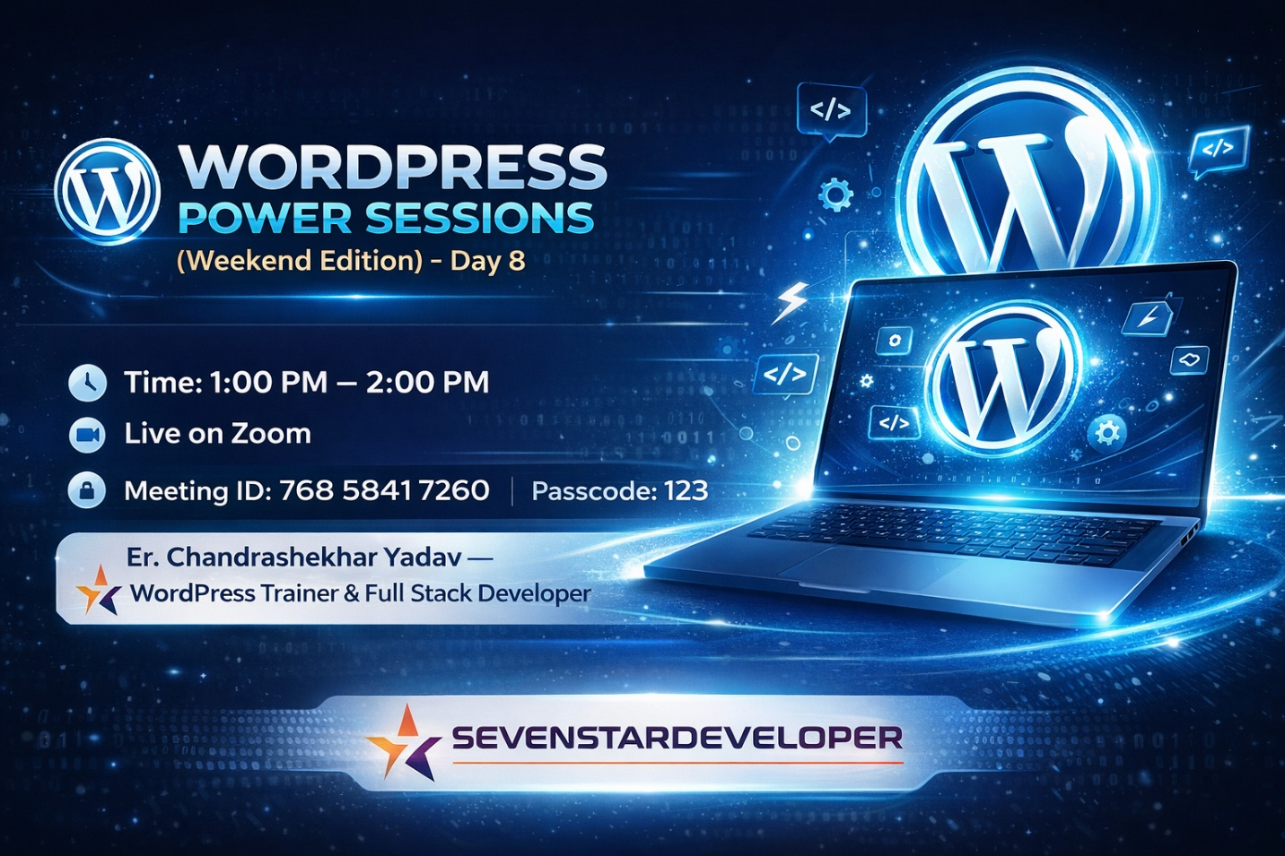

How To Add Social Share Buttons In WordPress 2025 Course
Hi! Welcome to the 8th lecture of the WordPress Course 2025. In today’s guide, we’ll learn how to add social share buttons to your WordPress website. Social share buttons allow visitors to share your content on platforms like Facebook, Twitter, WhatsApp, and more.

These buttons make it easy for your audience to spread the word about your site’s content. They improve your website’s visibility and bring in more traffic. We’ll use the AddToAny Share Buttons plugin in this tutorial. By the end, you’ll know how to install, activate, and customize the plugin to display share buttons on your site.

What Are Social Share Buttons?
Social share buttons are icons that let your visitors share your content directly to their social media accounts. These buttons can appear:
- On the side of your webpage as floating icons.
- At the top or bottom of your blog posts or pages.
- In a sticky bar that stays visible as users scroll.
Adding social share buttons encourages users to share your content. This helps your website gain more exposure on social media platforms.

Why Add Social Share Buttons?
There are several benefits of adding social share buttons to your site:
- Increase Traffic: When visitors share your content, it reaches a wider audience. This brings in more traffic to your website.
- Boost Engagement: Social sharing allows users to engage with your content by sharing it with their friends and followers.
- Improve SEO: Search engines notice when content is shared often, improving your site’s search rankings.
- User-Friendly: Social share buttons make it easy for your audience to promote your website.
Now that we know the benefits, let’s move on to the steps to install and activate these buttons.

Step 1: Installing the AddToAny Share Buttons Plugin
To start, we need to install the AddToAny Share Buttons plugin. Follow these simple steps:
- Log in to your WordPress dashboard.
- On the left-hand menu, click on Plugins.
- Select Add New.
- In the search bar, type AddToAny Share Buttons.
- Click on the Install Now button.
The AddToAny plugin is popular because it’s easy to use, lightweight, and supports multiple platforms. The installation process will take a few seconds.

Step 2: Activating the Plugin
After installing the plugin, you must activate it. Without activation, the plugin won’t work. Here’s how:
- Once the installation is complete, you’ll see an Activate button.
- Click on Activate to enable the plugin.
When the plugin is activated, you’ll see its menu in your WordPress dashboard. This is where you can customize the settings.

Step 3: Accessing the Plugin’s Settings
After activating the plugin, the next step is to access its settings. Here’s how:
- Go to your WordPress dashboard.
- Click on Settings.
- Select AddToAny Share Buttons.
This page lets you configure how the buttons will look and where they’ll appear on your website.

Step 4: Customizing the Social Share Buttons
Customization is key to ensuring the social share buttons match your website’s design and functionality. Here are some options you can customize:
- Add or Remove Services: Choose which social platforms (e.g., Facebook, Twitter, WhatsApp) to include.
- Placement: Decide where the buttons will appear—at the top, bottom, or sides of your content.
- Floating Icons: Enable floating icons that stick to the screen as users scroll.
- Icon Size: Adjust the size of the buttons to fit your design.
- Advanced Options: Add custom JavaScript or CSS for more control over the buttons' appearance.
Spend some time exploring these settings to make sure the buttons suit your site’s needs.

Step 5: Saving Changes
Once you’ve customized the buttons, it’s important to save your settings. Here’s how:
- Scroll to the bottom of the plugin settings page.
- Click on the Save Changes button.
After saving, refresh your website to see the updated social share buttons.

Step 6: Viewing Social Share Buttons on Your Site
Now, visit your website to check if the social share buttons are visible. Depending on your settings, the buttons might appear:
- As floating icons on the side of the page.
- Inline, at the top or bottom of your blog posts.
Click on a button to test if it works. This ensures visitors can share your content seamlessly.

Step 7: Advanced Features of AddToAny
The AddToAny plugin offers advanced features that make it even more useful. Here are a few:
- Custom Styling: Use CSS to style the buttons according to your website’s theme.
- Analytics Integration: Track how often your content is shared using tools like Google Analytics.
- Universal Button: Add a single button that gives users access to all available sharing platforms.
- Email Sharing: Allow users to share your content through email.
These features make AddToAny a versatile and powerful plugin for social sharing.

Troubleshooting Common Issues
If you encounter problems while using the plugin, here are some solutions:
- Buttons Not Displaying: Refresh your page or clear your browser cache.
- Compatibility Issues: Ensure your WordPress version is compatible with the plugin.
- Icons Not Loading Properly: Check if there’s a conflict with your theme or another plugin.
For further help, refer to the plugin’s support documentation or contact their support team.

Alternative Plugins for Social Sharing
While AddToAny is a great option, there are other plugins you can consider:
- Social Warfare: Offers stylish buttons and tracking options.
- Monarch by Elegant Themes: A premium plugin with advanced customization.
- Shareaholic: Includes social sharing and content recommendations.
These plugins have unique features and might better suit your specific needs.

FAQs
1. What are social share buttons?
Social share buttons are small icons that allow users to share your website content on social media platforms.
2. Why are social share buttons important?
They increase your content’s visibility, improve SEO, and drive traffic to your site.
3. How do I install the AddToAny Share Buttons plugin?
Go to your WordPress dashboard, click on Plugins, search for "AddToAny Share Buttons," and click Install Now.
4. Can I customize the social share buttons?
Yes, you can customize their size, placement, and the social platforms they support through the plugin settings.
5. What should I do if the buttons don’t appear on my site?
Try refreshing your page, clearing your cache, or checking for compatibility issues with your theme or other plugins.

Conclusion
Adding social share buttons to your WordPress site is a simple and effective way to increase traffic and engagement. By using the AddToAny Share Buttons plugin, you can easily install, activate, and customize these buttons to match your website’s design.
Social share buttons make it easy for visitors to share your content, helping you reach a wider audience. Start adding social share buttons to your site today and see the benefits for yourself!

🛍️ What is WooCommerce? A Complete Guide! 🚀
Welcome to another insightful tutorial with Sevenstardeveloper! In this video, Taha will explain WooCommerce and how it helps you build a powerful online store. 🏪✨
📌 What You’ll Learn In 2025:
✅ What is WooCommerce & why it’s popular? 🔥
✅ How WooCommerce helps in creating online stores 🛒
✅ Customization options for a unique shopping experience 🎨
✅ Best tips to grow your eCommerce business 📈

🛒 How To Setup Woocommerce In WordPress? | WordPress Tutorial for Beginners 2025 | Hindi 🛒

In this video, we will show you how to install WooCommerce in WordPress and complete the first setup wizard step by step. If you're setting up an online store for the first time, this tutorial will help you get started quickly!
🔹 Install WooCommerce in WordPress
🔹 Complete the setup wizard
🔹 Configure basic store settings
This is a beginner-friendly guide, so follow along and set up your WooCommerce store with ease!

Thank You!
Subscribe for more WordPress & WooCommerce tutorials 🚀
youtube.com/@sevenstardeveloper

